Visualization Tool for

Electric Vehicle Charge &

Range Analysis

Introduction:

The Electric Vehicle (EV) is not new, but it has been receiving significantly more attention in recent years. Advances in both EV analytics and battery technologies have led to increased automotive market share. The modern mechatronic vehicle marries electrical storage and propulsion systems with electronic sensors, controls, and actuators, integrated closely with software, secure data transfer, and data analysis, to form a comprehensive transportation solution. Advances in all these areas have contributed to the overall rise of EV’s, but the common thread that runs through all these elements is data analytics.

Purpose:

The purpose of electric vehicle (EV) charge and range analysis is to help EV owners and users optimize their driving experience and reduce range anxiety. By analyzing the charge and range of an EV, users can better understand how far they can travel on a single charge and plan their trips accordingly.

Here are some specific purposes of electric vehicle charge and range analysis:

1. Planning trips: Electric vehicle charge and range analysis can help drivers plan their routes based on the availability of charging stations and the range of their vehicle. This can help reduce range anxiety and ensure that the driver has a plan in case their vehicle runs out of charge.

2. Optimizing charging: By analyzing the charging patterns of an EV, users can optimize their charging behavior to ensure that their vehicle is fully charged when they need it. This can help reduce charging time and ensure that the vehicle is always ready to go.

3. Comparing EV models: Electric vehicle charge and range analysis can help drivers compare different EV models to determine which one best fits their needs. This can include factors such as driving range, charging time, and cost.

4. Estimating costs: Electric vehicle charge and range analysis can help users estimate the cost of charging their EV and compare it to the cost of owning a gasoline-powered vehicle. This can help users make informed decisions about the cost-effectiveness of EV ownership.

Problem Definition & Design Thinking:

Empathy Map



Brainstorming & Ideation

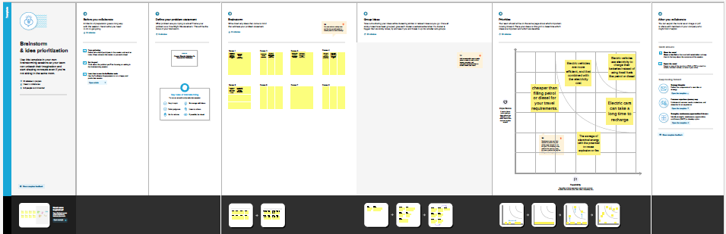

Result:

Top 10 Most Efficiency Brands

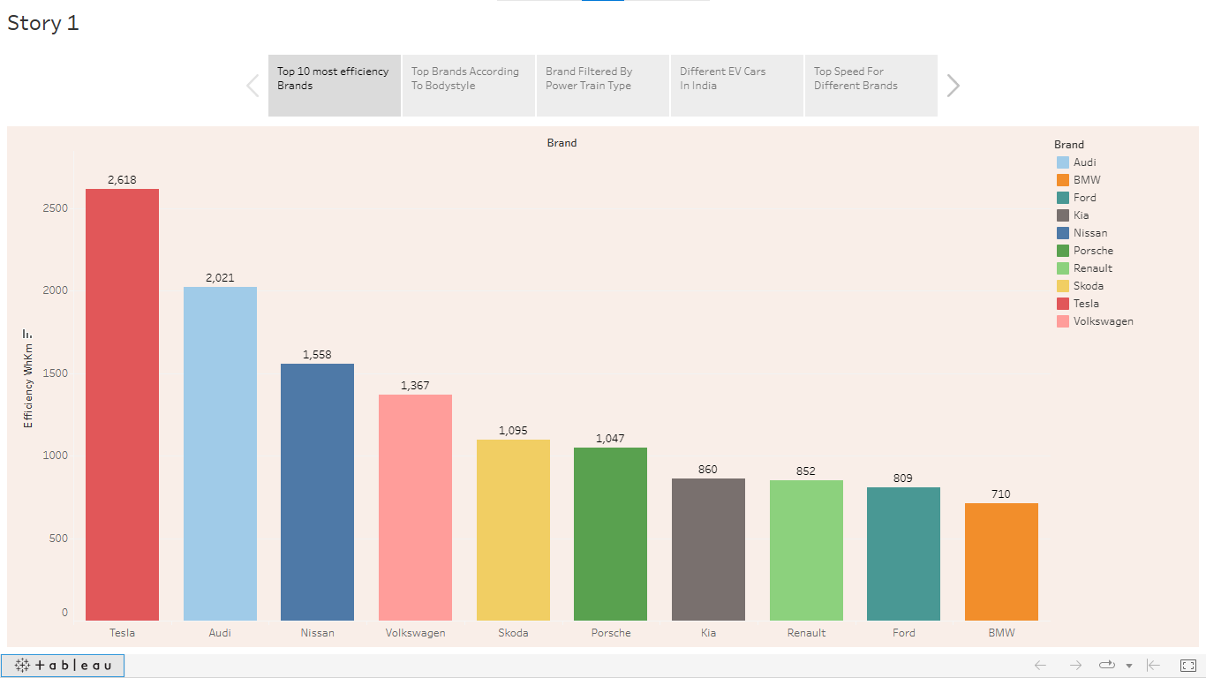

Top Brands according To Body styles



Brands Filtered By Power Train Type



Different EV Cars in India



Top Speed for Different Brands

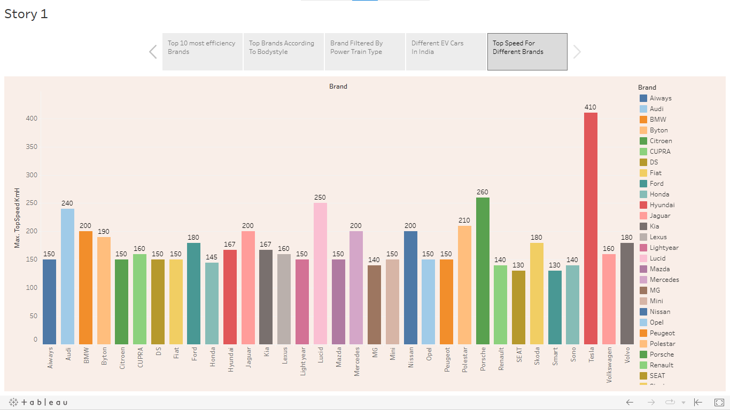

Dashboard 1

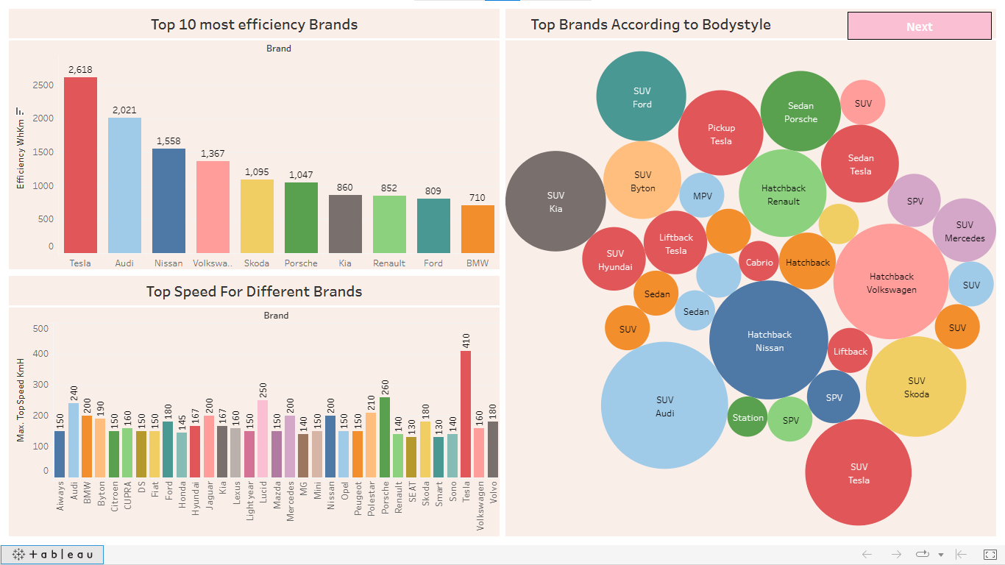

Dashboard 2

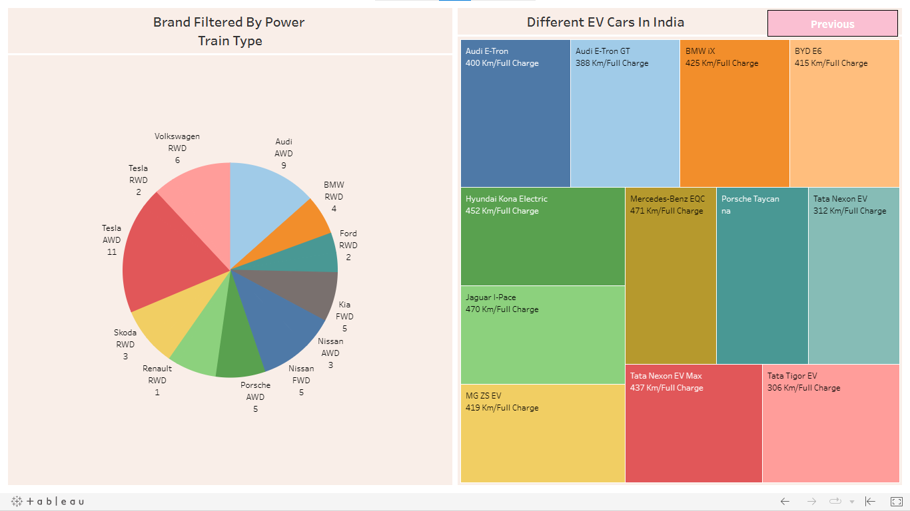

Advantages & Disadvantages:

Advantages:

1. Environmental Benefits: Electric vehicles have lower emissions compared to traditional gasoline-powered vehicles. They can reduce greenhouse gas emissions, air pollution, and dependence on fossil fuels, making them a more environmentally friendly option.

2. Energy Efficiency: Electric vehicles are more energy efficient than gasoline-powered vehicles, converting up to 60% of the energy stored in their batteries into motion.

3. Lower Operating Costs: Electric vehicles are cheaper to operate than gasoline-powered vehicles. They require less maintenance, have fewer moving parts, and are more efficient, leading to lower fuel costs and lower overall operating costs.

4. Quiet and Smooth Operation: Electric vehicles produce less noise and vibration than traditional gasoline-powered vehicles, providing a quieter and smoother driving experience.

Disadvantages:

1. Limited Range: Electric vehicles have a limited driving range compared to traditional gasoline-powered vehicles. They typically require charging after about 100-300 miles, which can be inconvenient for long-distance travel.

2. High Upfront Cost: Electric vehicles are generally more expensive to purchase than gasoline-powered vehicles. This can be a barrier to entry for many consumers.

3. Charging Time: Electric vehicles take longer to charge than gasoline-powered vehicles take to refuel. This can be inconvenient for drivers who need to charge their vehicle while on the road.

4. Charging Infrastructure: Electric vehicle charging infrastructure is not as widespread as traditional gasoline refueling infrastructure. This can make it difficult for drivers to find a charging station, especially in rural areas.

Applications:

Electric vehicles (EVs) have several applications across different sectors. Here are some of the main applications for electric vehicle cars:

1. Public transportation: Electric vehicles can be used in public transportation, including buses and trains. Electric buses are becoming increasingly popular, with many cities around the world adopting electric buses in their public transportation systems.

2. Commercial transportation: Electric vehicles can be used for commercial transportation, including delivery vehicles and trucks. Electric trucks are well-suited for short-haul trips and are becoming increasingly popular in the logistics and transportation industries.

3. Shared mobility: Electric vehicles can be used in shared mobility services, such as car-sharing and ride-sharing. Electric vehicles are well-suited for these services because they are easy to charge and have lower operating costs than traditional gasoline-powered vehicles.

4. Emergency response: Electric vehicles can be used by emergency responders, such as police and fire departments. Electric vehicles offer quick acceleration and low noise levels, making them well-suited for emergency situations.

Conclusion:

Electric vehicles offer several advantages over traditional gasoline-powered vehicles, including environmental benefits, energy efficiency, lower operating costs, and quieter operation. However, they also come with some disadvantages, including limited range, high upfront costs, longer charging times, and a lack of charging infrastructure.

Future Scope:

The future scope for electric vehicles (EVs) is very promising, as they are expected to play a significant role in the transition to a more sustainable transportation system.

1. Increased Adoption: EVs are expected to become more widespread in the coming years, with many countries setting ambitious targets to phase out gasoline-powered vehicles.

2. Improved Battery Technology: Battery technology will help to reduce the cost of EVs and increase their convenience and appeal to consumers.

3. Charging Infrastructure: Charging infrastructure will help to reduce range anxiety and make EVs more convenient for long-distance travel.

4. Autonomous Driving: Autonomous driving technology is expected to become more widespread, which will make EVs even more convenient for consumers.

Appendix:

Tableau Public Dashboard Link:

<https://public.tableau.com/views/VisualizationToolforElectricVehicleChargeandRangeAnalysisDashboard/Dashboard1?:language=en-US&:display_count=n&:origin=viz_share_link>

Tableau Public Story Link:

<https://public.tableau.com/views/VisualizationToolforElectricVehicleChargeandRangeAnalysisstory/Story1?:language=en-US&:display_count=n&:origin=viz_share_link>

Project link:

<file:///C:/Users/Karthik/Desktop/Visualization%20Tool%20for%20Electric%20Vehicle%20Charge%20and%20Range%20Analysis/Electric%20vehicle%20Tableau/index.html>

Video Link:

<https://drive.google.com/file/d/1bjPkazdurvBwha5t3p2x6v7AIR79zFd_/view?usp=share_link>